Located in the Lincoln
SAFEWAY CENTER
61 Lincoln Blvd., Suite A
Lincoln, CA 95648
Phone: (916) 408-0103
Fax: (916) 408-0117
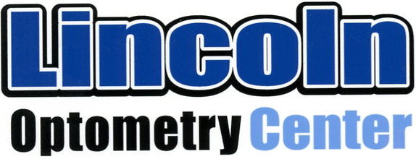
A Professional Corporation

DIGITAL RETINAL
CAMERA SCREENING

ADDITIONAL PATIENT TESTING OPTION………… $25

THIS TEST IS NOT REQUIRED FOR AN EYE HEALTH EXAM, BUT IS RECOMMENDED BY DR. PROIETTE, AS IT GIVES ADVANCED INFORMATION FOR FORMING DIAGNOSES EARLIER. THIS CAN MINIMIZE THE EFFECTS TO YOUR VISION ON ANY DISEASES FOUND. THIS DOES NOT REPLACE A DILATED EXAM.

The Synamed Digital Retinal camera is used before your routine eye exam, taking a picture of the inside of your eye using a computer-assisted camera. These photos can be looked at years later to evaluate for subtle changes, for monitoring progress of diabetes, glaucoma, macular degeneration, or other retinal diseases just to name a few. This screening takes approximately 5 minutes.

As with other new advanced equipment, your insurance plan may not cover the cost of this screening.

YES, I want to take advantage of the SDR camera and
will pay the $25 fee today.

NO, I decline this additional test.

Signature: ___________________________ Date: ____________________

Digital Retina Camera Screening (Rev.4/1/16)

